Issue: Failed to get ckt_id from USRP database

Reference ticket: 246907189

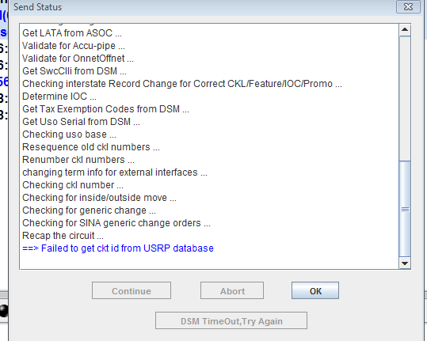

Step 1: Check the logs in clpi055 machine

/opt/frame/log/ot_server

ls –ltr *userid*

sample file name would be similar to DB-PL.Debug.kz216g_retail.20180628

Step 2: check for circuit_id in logs

Step 3: Check valid_ind in circuit table

select valid_ind from circuit where circuit_id=1077099.

update the value to N.

update circuit set valid_ind=’N’ where circuit_id=1077099.

Step 4: Ask user to reopen order in USRP and retry